Jenkins Security and User Account Management

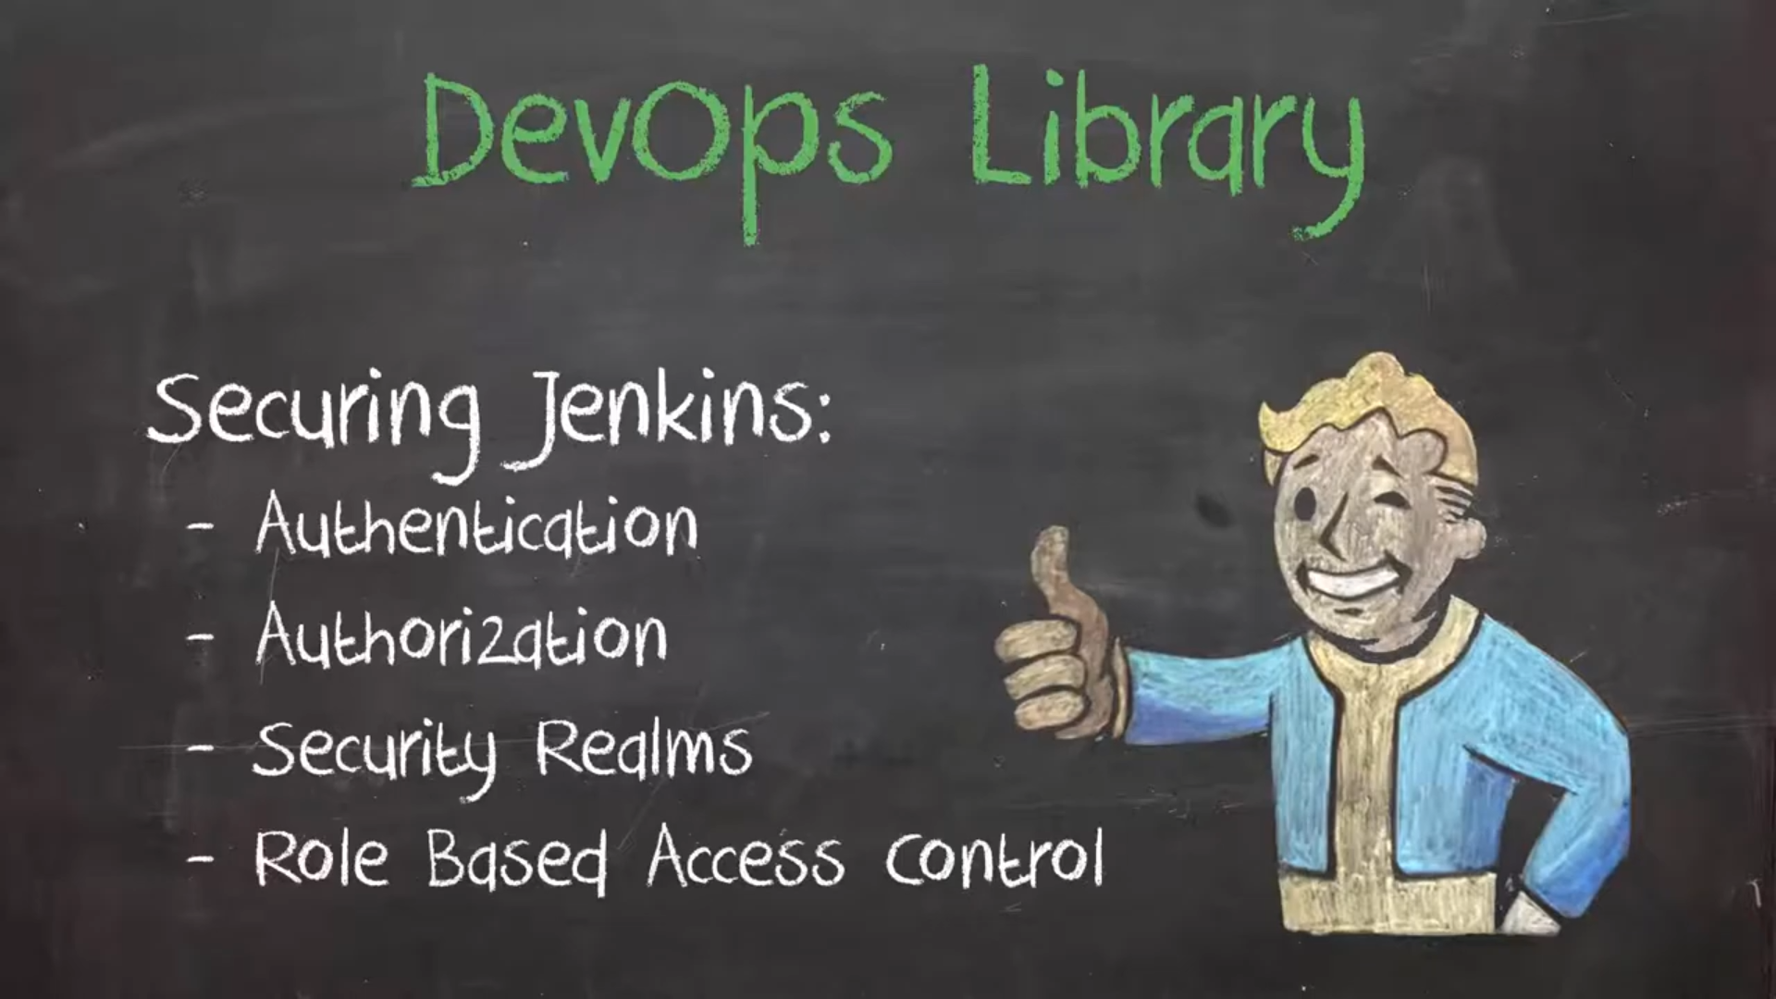

1. Access Control:

